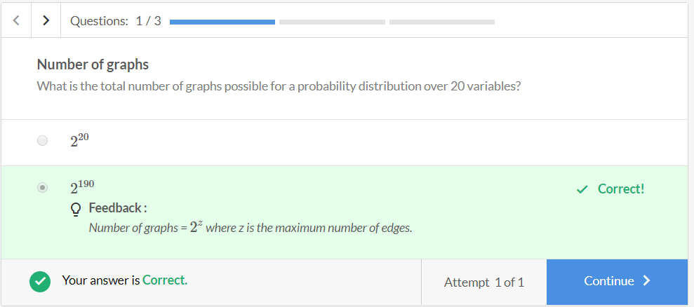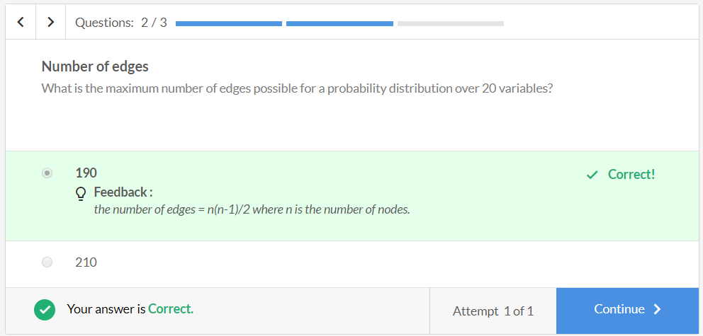

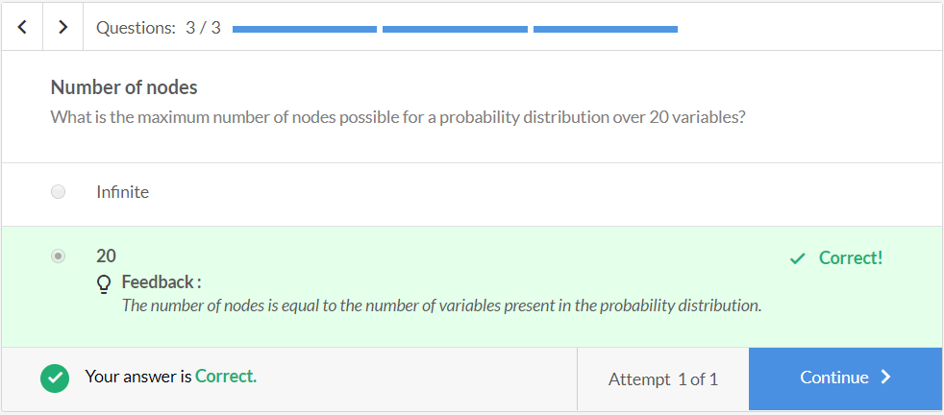Let's understand this with the help of a simple quiz. Given below are three probability distribution tables of  x1 and x2 where both  x1 and x2 take values either 0 or 1.

|  |  |  |
| --- | --- | --- |
| Distribution 1 | | |
| x1 | x2 | probability |
| 0 | 0 | 0.2 |
| 0 | 1 | 0.3 |
| 1 | 0 | 0.2 |
| 1 | 1 | 0.3 |

|  |  |  |
| --- | --- | --- |
| Distribution 2 | | |
| x1 | x2 | probability |
| 0 | 0 | 0.2 |
| 0 | 1 | 0.1 |
| 1 | 0 | 0.7 |
| 1 | 1 | 0.2 |

|  |  |  |
| --- | --- | --- |
| Distribution 3 | | |
| x1 | x2 | probability |
| 0 | 0 | 0.06 |
| 0 | 1 | 0.24 |
| 1 | 0 | 0.14 |
| 1 | 1 | 0.56 |

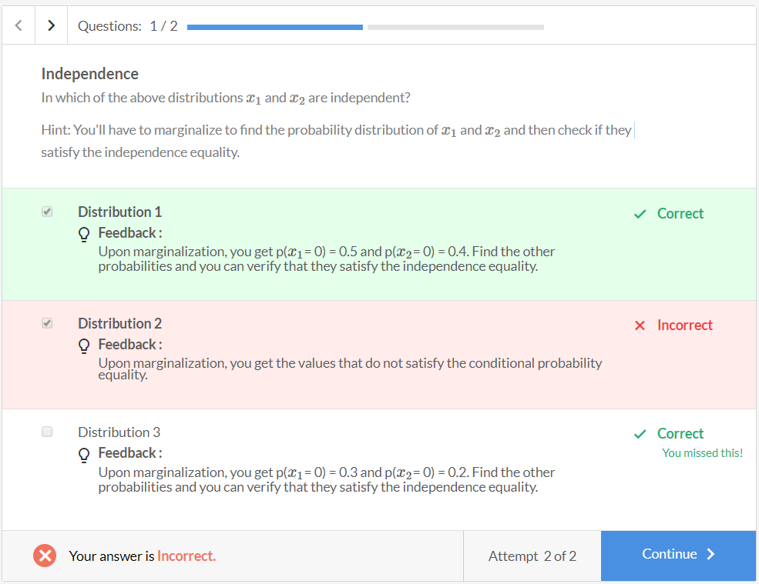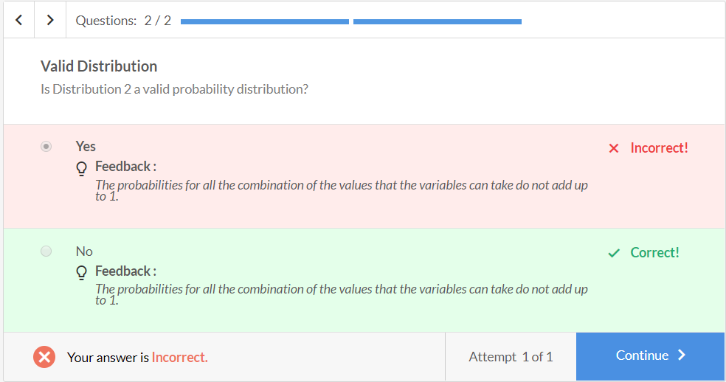

Answer the questions given the following probability distribution table.

|  |  |  |  |
| --- | --- | --- | --- |
| Joint Probability Distribution | | | |
| x1 | x2 | x3 | Probability |
| 0 | 0 | 0 | 0.024 |
| 0 | 1 | 0 | 0.036 |
| 1 | 0 | 0 | 0.096 |
| 1 | 1 | 0 | 0.144 |
| 0 | 0 | 1 | 0.049 |
| 0 | 1 | 1 | 0.441 |
| 1 | 0 | 1 | 0.021 |
| 1 | 1 | 1 | 0.189 |

